*Contact tracing using Pega*

* *Sathya Thangaraj(*[*Sathya.thangaraj@tcs.com*](mailto:Sathya.thangaraj@tcs.com)*) and Jaghadish Rajagopalan (*[*jaghadish.r@tcs.com*](mailto:jaghadish.r@tcs.com) *)*

**Synopsis**

With the world heavily potentially impacted due to Covid-19 and with no new vaccine discovered yet, Contact tracing becomes significant in terms of controlling the spread and selective opening of the business to run and boost the economy

Contact tracing on other hand is more tedious and the scalability of the same is more challenging in tracing contact of each people.

The technological growth opens up a possibility of better tracking (GPS/location tracking/wifi tracing etc) but that also comes with more risk on privacy – how would once go ahead and provide a blank consent to let anyone track on them?

This curious case of privacy concern enabled opened up a new possibility of letting anyone understand if they had been exposed to any covid-19 positive patients – with a new technology – Decentralized Privacy Preserving Proximity Tracing (DP3T)

**Idea**

The idea is an excerpt based on the github link from Nicky Case - <https://ncase.me/contact-tracing/>

Which details Protecting Lives and Liberty – how tracing apps can foil both COVID-19 and Big Brother. An excerpt on the process is given below:

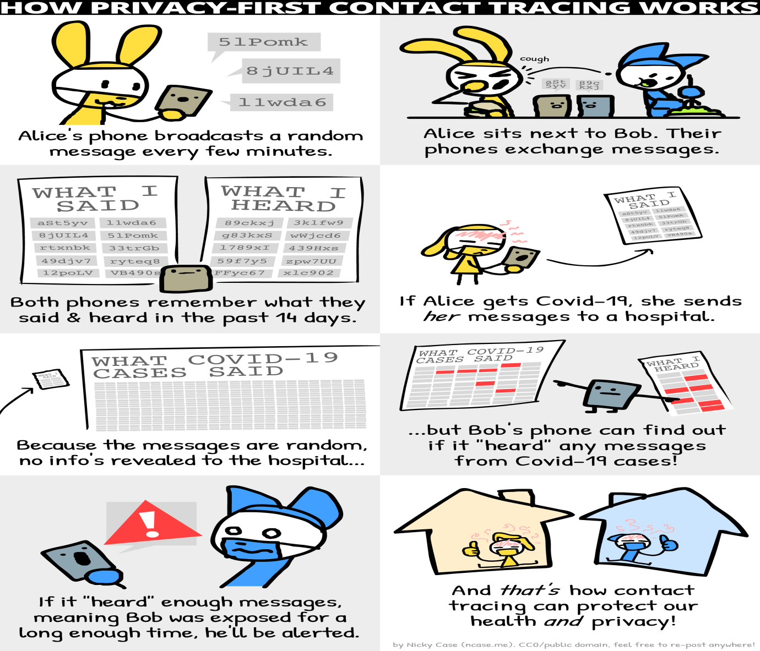

As part of this hackathon, a prototype based on the above diagram was established, with integrating capabilities of Pega to establish connectivity in reading the logs from privacy enables logs, process them in pega and maintain a common repository for anyone to check if they had been exposed to anyone suffering from COVID-19

Technical Implementation:

**Use Case 1 – Patient Registration process**: A patient gets admitted in hospital and unfortunately tested positive for CovID-19. An optional entity is included on the application log if User is interested to send the DP3T logs for central repository storage. The user can decide to either share or restrict the logs to be uploaded on central repository

When the user consent is given – One type password is sent to patient exclusively for him to upload the DP3T logs into central repository

The user then logs into his account using the random code that was sent to the patient as one time password.

Once the login is successful – the user is then able to update the logs in central repository. The data is then stored in pega database

**User story 2**

A user comes randomly and access repository to check if had been in recent contact with anyone off-late who had been diagnosed to be infected with COVID

The user follows a similar process – request for sending aOne time password to his mobile and then uploads his log that had recently listened to all the people who he had been in close contact

The log is designed to contain data for 14 days with start and end time of contact.the minutes exposed are calculated with the difference between start and end time

The user A (currently diagnosed with COVID-19) and User B (one who randomly wishes to check if he/she had been in touch with anyone recently infected with COVID-19) sends and listens some random messages using bluetooth tech in the app installed – this efficiently eliminates the risk of tracking personal details of people and their personal details like Name, Address, GPS location etc.

Two scenarios are possible – if the person does not get in close contact with anyone, a notification would pop up informing that user is safe; on the other hand, if the user had been in contact with multiple people – the cumulative minutes of hours exposed to the infected will be displayed and a suggestion to take up self-isolation or plan for a test would be proposed.

Advantages:

* Enhances privacy – serious concerns on privacy is eliminated
* The current apps available are restricted to geography – enabling such decentralised apps could enable efficient contact tracing
* Highly secure – means more hack-proof – the Bluetooth information are stored with unique id of random gibberish letters which makes it hard for hacking or compromising secure details shared
* Room for improvement – this is being discussed seriously among industrial peers such as Google/Apple for efficient tracking and is constantly looking for room on improvement in its tracking and maintanence of records

Shortcomings

* The tracking although is more efficient and highly secure – it requires a serious marketing to establish the secure aspect of DP3T
* it is dependent on Bluetooth, which although proven to be more secure – is seemingly outdated compared to current tech advancements
* The establishments of app is not been developed from any industrial experts on the field – this is to ensure trust to customer and promote this to be in use through the globe
* Aim to reach 60% of the use is a tedious task – Efficient contact tracing requires atleast efficient tracking of 60% of people who are exposed to the infected people

Technical improvements that could be done on the app built

A prototype model to run through this approach is only developed – this model is used for demo purpose of the idea that runs behind the contact tracing

We fully understand Pega has distinguishing capabilities of all the external screens(called as DP3T app) to cover this scenario – but owing to limitations on the build and also on timeline, we had simulated the response to facilitate the demo